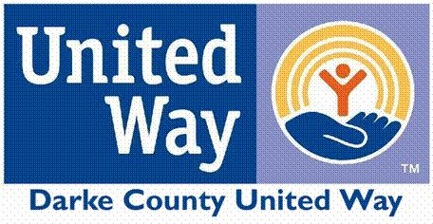

COMMUNITY FUND

Organization __________________________________________________

Address______________________________________________________

Phone_______________________________________________________

Program Name (if different than above) ____________________________

Amount requested____________________

Contact Person ________________________

Address______________________________

Phone________________________________
Email ________________________________

I hereby certify that this organizations’ governing body has given requisite approval for submission of this application and that all facts, figures and representations made in this application are true and correct to the best of my knowledge.

________________________ ____________________ _________________
Signature Title Date

Please RESPOND to the following questions; use a separate attachment if more room is needed.

- Describe your organization/project and its purpose.

- Specifically state and explain the project you are looking to receive funding towards and how many citizens of Darke County you foresee being impacted.

- If the maximum amount of money from the Community Fund will not totally fund your project, please outline when, where, and how you raise the rest of the funds required.

- Please outline the program’s budget and exactly how the United Way’s funds will be spent.

- If this project/program is a collaborative effort, please outline the succession plan established by the partnering groups.

- Additional comments about the request.

ATTACHMENTS:
- Please include a copy of the organization’s 501© 3 exemption letter from the Internal Revenue Service.
- Please complete the attached Anti-Terrorism Agreement
- Please include a list of the Board of Directors and/or volunteers and employees that are involved in this initiative.
Darke County United Way
2023 Anti-Terrorist Certification

I certify that, as of the date on which this application is being submitted to the Darke County United Way, the organization named below does not knowingly employ individuals or contribute funds to entities or persons on either the Department of Treasury’s Office of Foreign Assets Control Specially Designated Nationals List or the Terrorist Exclusion List. Should any change in circumstances pertaining to this certification occur at any time, the organization will notify the Darke County United Way immediately.

CPO (Chief Professional Officer) or
Executive Director Signature: ____________________________________________________

Typed or Printed Name: ________________________________________________________

Name of federation or member charity: ___________________________________________

Date: _________________

Certification provided for the 2023 Darke County United Way.

